### **Networked Computers Simulation**

1. **Simulation Using GNS3**

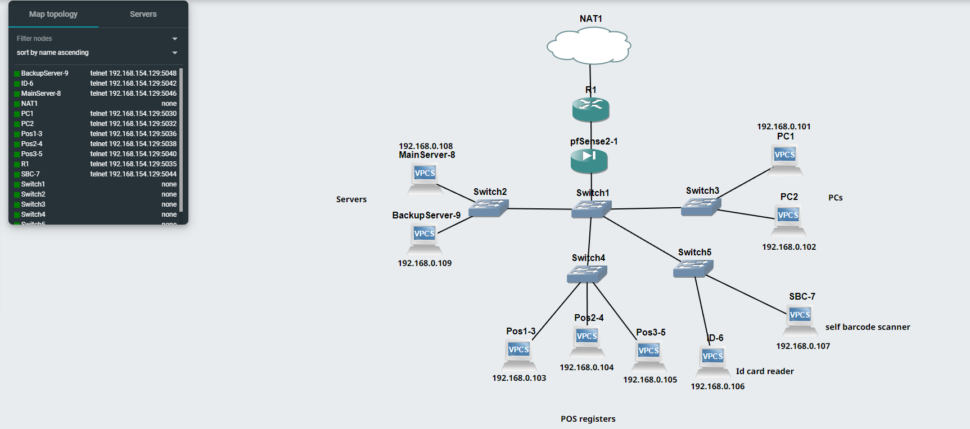

*Figure 4. GNS3 Simulation Design*

In this section of paper, we are going to simulate the process inside the network, including packet. In above simulation, all devices including servers and POS registers are simulated as VPC, which the IP Addresses of the devices are statically assigned, except of the Router interface which is connected to the NAT (Network Address Translation) with DHCP (Dynamic Host Configuration Protocol) system.

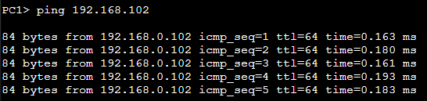

*Figure 5. Ping Testing* from PC1 to PC2

In Figure 5, we try to give the ping command in PC1 Command Prompt to PC2. A total of 5 packets are sent and successfully received by a peer device which sends acknowledgements.

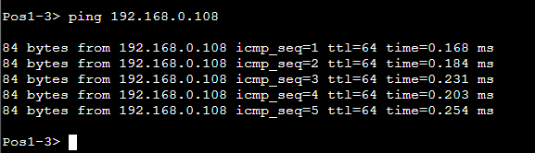

*Figure 6. Ping Testing from POS to main server*

In Figure 6, we try to give a ping command in Pos1 Command Prompt to the main server. 5 packets are sent and successfully received by the main server which sends acknowledgements.

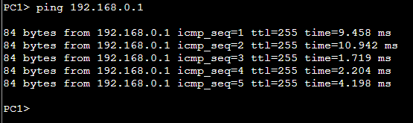

*Figure 7. Ping testing from PC to router*

In Figure 7, we try to give a ping command in pc1 Command Prompt to the router with 5 packets sent. This result shows a longer response time compared to the previous ping attempts.

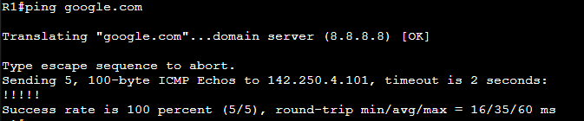

*Figure 8. Router Ping Testing to google.com*

In this case, we tried to simulate a communication between the router with www.google.com, in which the router sent five packets to the google server and also received five acknowledgements. So all packets are successfully sent with zero percent of loss rate. Pinging to other domain servers will provide the similar results.

Above Network Simulation is uploaded to this GitHub Link :

<https://github.com/anoodleReza/JarkomAssignmentSimulation>

Reference:

[1] University of the Pacific, “Lab 1 - GNS3 Setup”, 2016, <https://cyberlab.pacific.edu/courses/comp177/labs/lab-1-gns3> [Accessed 8 Sept 2022]

[2] GNS3, “Your First GNS3 Topology”, 2021, <https://docs.gns3.com/docs/getting-started/your-first-gns3-topology> [Accessed 8 Sept 2022]